Festivals and Landmarks:

**Panagbenga Festival** – Came from the Malayo-Polynesian origin which means “season of blooming”. It is an annual festival, as a tribute to the city’s earthquake happened on the 90’s. The event consists of floats, street dance, flower-inspired costumes that are open to all people of Baguio and even from all around the world, where some of them goes to Baguio just to watch Baguio’s Panagbenga festival and is usually held on the last week of February.

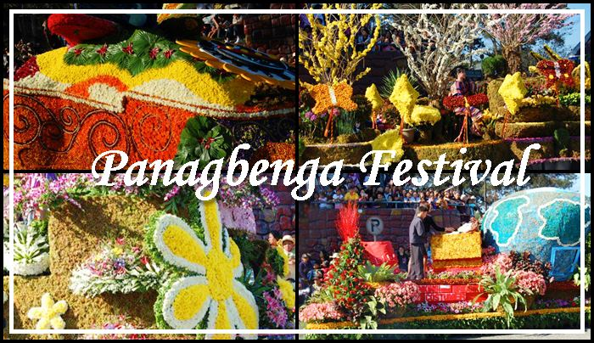

Photo from: Jojo Vito

**Adivay Festival** – An Ibaloi term which means “coming together and having fun”, where people from different tribes gather together to showcase their different beliefs, practices, and even products. This event is being held every November, and was focused on the Agri-Tourism for promoting its history, culture, arts, trades and industries.

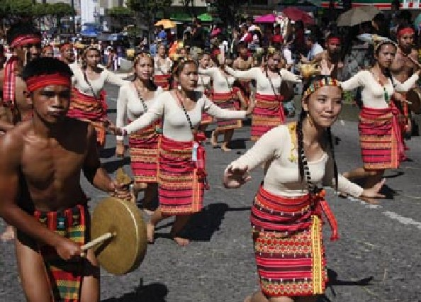

Photo from: yourviet.blogspot.com

**Ulalim Festival** – Ulallim means “epic or story”. A celebration held every February for founding of the Province, Kalinga’s provincial separation from Apayao, where their cultures and traditions are being shown.

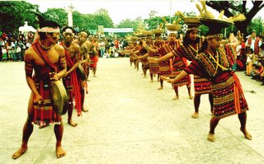

Photo from: Juny La putt

LANDMARKS

**Banaue Rice Terraces** – Knowns as the “Eighth Woder of the World”; Carved into the mountains of Ifugao, by the Ifugao tribes 2000 years ago, where they can plant rice and vegetables. Years have pass, it shows signs of erosion and drought, yet people still go here because of its beautiful scenery.

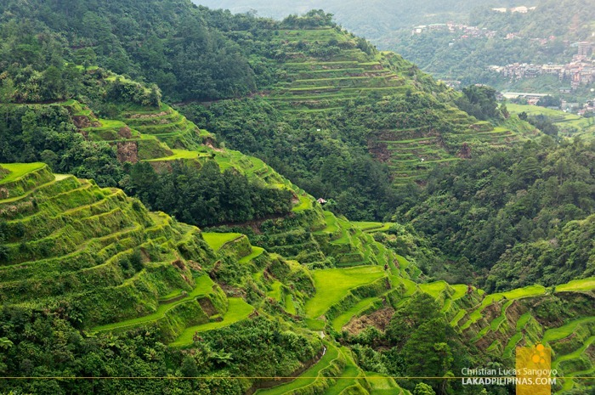

Photo from: Christian Lucas Sangoyo

**Sumaguing Cave** – Also called the “Big Cave” for having the largest chambers of all the caves in Sagada. It is a big check for adventurous people, having its excellent limestone formation down to finding the ice-cold water inside the cave.

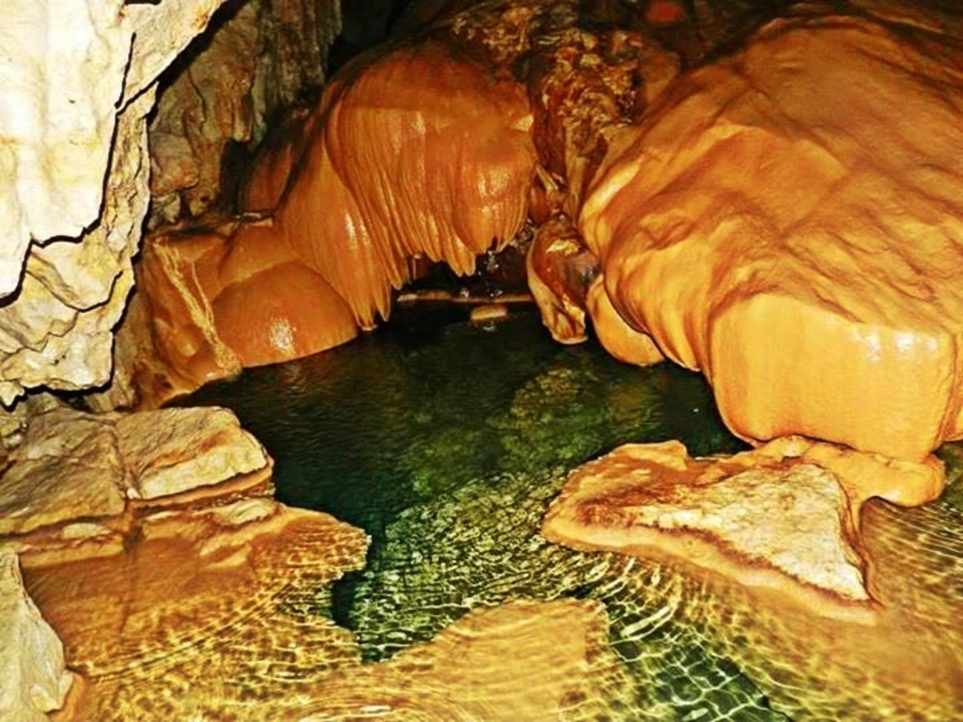

Photo from: Maya Uyan

**Kabayan Mummy Burial Caves** – A traditional practice of having rituals for giving honour to the dead with the use of mummification. After the long process, it will be placed on pinewood coffin and hang it in caves or solid rocks. UNESCO declared this as an endangered site.

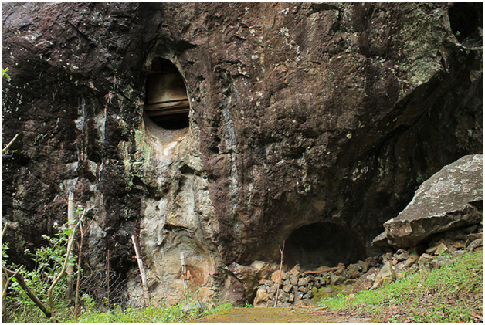

Photo from: nup

**Mount Pulag** – It is the highest mountain in Luzon, and 3rd in the Philippines. A perfect getaway for those who loves to hike. It’s “sea of clouds”, Milky Way Galaxy’s view, and cool breeze make it more attractive to tourist.

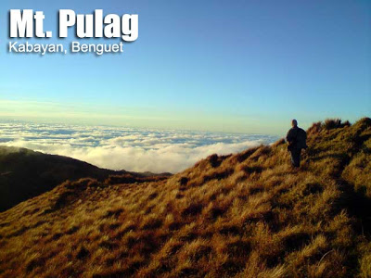

Photo from: Ivan Henares

**Tam-Awan Village** – A village where you can find different Igorot Huts which are freely accessible to go into. It gives people the experience on how Igorots’ house looks like, how they can adopt their atmosphere to get a view of a mountain people’s life. It is called Tam-awan because of its magnificent view of China Sea’s sunset, calling it a vantage point.

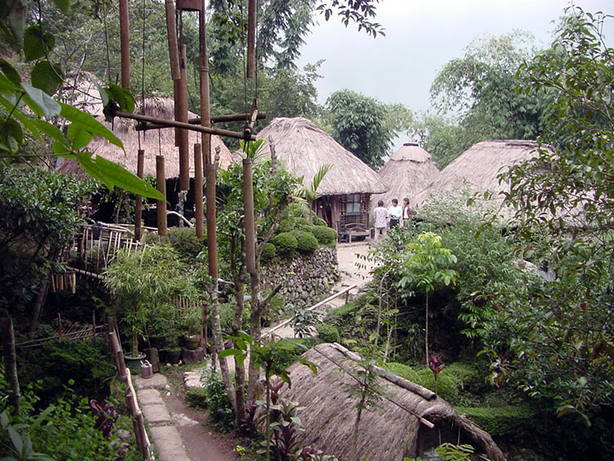

Photo from: Juny La Putt

**Diplomat Hotel** – One of the most haunted places in the Philippines, for its old-vintage look since it has been a refuge house during the World War II.

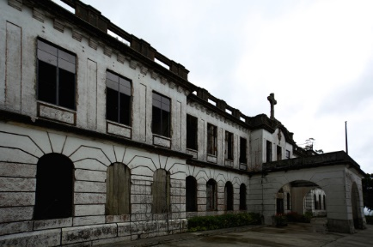

Photo from: Eric Banes